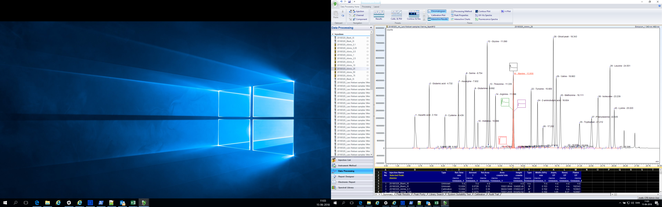

Amino acids by HPLC Emission_1

Amino acids by HPLC Emission_2

